Scotland Golf and Ryder Cup Tour

Hotel Accommodations in Scotland

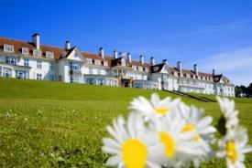
Turnberry Resort
Arrive Date: September 26, 2010
Depart Date: September 27, 2010
No. of People: 8
No. of Nights: 2
Room Details: 4 x Classic Twins
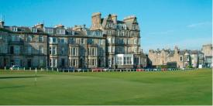
Rusacks Hotel
Arrive Date: September 28, 2010
Depart Date: September 30, 2010
No. of People: 8
No. of Nights: 2
Room Details: 4 x Standard Twins

Golf Plan in Scotland
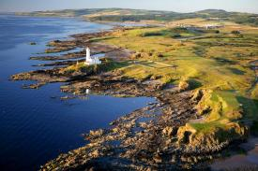
Turnberry Ailsa
Date of Play: September 26, 2010
Tee Time: PM
No. of Golfers: 8
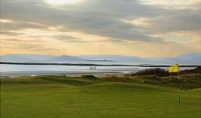
No. of Times: 2

Royal Troon Golf Club
Date of Play: September 27, 2010
Tee Time: TBA
No. of Golfers: 8
No. of Times: 2
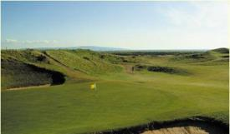
Lunch and Troon Portland
Date of Play: September 27, 2010
Tee Time: OPTIONAL
No. of Golfers: 8
No. of Times: 2
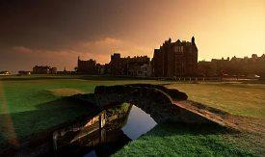
St. Andrews Old Course
Date of Play: September 28, 2010
Tee Time: BALLOT
No. of Golfers: 8
No. of Times: 2

St. Andrews Old Course
Date of Play: September 29, 2010
Tee Time: BALLOT
No. of Golfers: 8
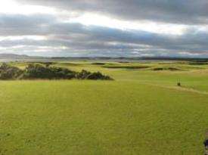
No. of Times: 2

St. Andrews New of Jubilee GC
Date of Play: September 29, 2010
Tee Time: TBA
No. of Golfers: 8
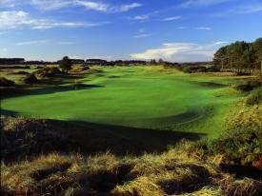
No. of Times: 2

Carnoustie Championship
Date of Play: September 30, 2010
Tee Time: AM
No. of Golfers: 8
No. of Times: 2

You will depart the USA on September 25, 2010 and arrive into Glasgow on September 26, 2010. Your driver guide will meet and greet you at airport in Glasgow on September 26. He will help you with your luggage to your luxury golf coach. You will transfer to Turnberry Resort where you will play your first round of golf at Turnberry Ailsa in the afternoon on the 26th. There are flight from SFO through Newark that arrive Glasgow at 8:00am. If you prefer to arrive on the 25th, we will be glad to help you with a hotel in Glasgow. The 27th you will play Royal Troon in the morning, have lunch and play Troon’s Portland course in the afternoon. On the 28th you will transfer to the Rusacks Hotel and play golf for the next 3 days in St. Andrews at courses listed above. We will enter all eight names each day in the Old Course ballot for tee times. We expect to get tee times through the ballot but if we do not we will instruct you how to walk out your front of the Rusacks and how to work with the starter to Old Course which is only a 9 iron away.

About the Hotels

Rusacks Hotel, St Andrews

Opened in 1887, Rusacks Hotel preserves a genuine warmth and intimacy of style, which makes it a revered St Andrews tradition, which, over the years, has hosted many top players, as well as rock and roll legends and other celebrities.
With just 48 rooms and suites, many overlooking the golf course and St Andrews Bay, the hotel has a peaceful, club-like mood and boasts a quality of service which fosters a sense of wellbeing. Magnificent windows look out on green panoramas, shimmering seas and limitless skies.
Here, St Andrews magnificent Old Course is no more than a firm putt from your door. An easy chip brings you to the beckoning shops, hostelries and history of St Andrews town and a full three wood is all you need to reach one of Scotland’s finest stretches of sand, reaching for miles along this glorious east coast.

St Andrews Old 0 min. St Andrews Castle 10 min.
St Andrews New 0 min. Crail 15 min.
St Andrews Jubilee 0 min. Elmwood Golf Course 25 min.
Dukes 0 min. Leven 30 min.
St Andrews Kittocks 0 min. Lundin Links 30 min.
St Andrews Torrance 0 min. Panmure Barry 42 min.
Kingsbarns 10 min. Carnoustie 45 min.

Turnberry Hotel, Turnberry

Located on the stunning Ayrshire coast just 55 minutes from Glasgow Airport and 30 from Prestwick, Turnberry is recognized as one of the world’s finest resorts delivering a myriad of unrivalled facilities, including an award winning Spa and variety of outdoor activities.
Turnberry is synonymous with golf and offers visitors the opportunity to play on two world-class championship links courses. The world famous Ailsa has hosted the prestigious Open Championships on no fewer than three occasions (Watson in ’77, Norman in ’86 and Price ’94) while the Kintyre was listed as one of 5 best new golf courses in the British Isles by Golf World magazine. The nine-hole Arran course is perfect for that second round of the day or to play in between visiting the many attractions The Westin Turnberry Resort has to offer. To help you prepare for the Turnberry golfing experience, the superlative Colin Montgomerie Links Golf Academy offers the very latest teaching and practice facilities.
A total of 221 rooms include 21 suites, 12 Luxury Lodges and 9 Cottages. All rooms have large bathrooms with showers, bathrobes, heated towel rails and hairdryers.
Spa: There is not better way to relax and unwind than in Turnberry’s exclusive Health Spa. Here everything is designed to restore the perfect balance of body and mind, by reducing stress and increasing well-being.

Wales and the Ryder Cup

You will fly from Scotland on Friday, 10/1/2010 to Bristol where your Ryder Cup host will meet and transfer you from the airport to your hotel. You will attend the Ryder Cup on Saturday and Sunday at Celtic Manor Resort.

We have you booked in Park Inn in Cardiff which is 17 miles from Celtic Manor. Park Inn Hotel is in the heart of the city, the Park Inn Cardiff City Centre Hotel is just minutes from the Cafe District. Close to Cardiff Castle, Millennium Stadium, Cardiff Bay, National Museum of Wales and wonderful pubs. The Hotel offers 146 brand new, newly-refurbished guest rooms. The RGB Red Bar & Grill offers full-service dining.

Your Scotland and Ryder Cup tour includes:

- 8 nights’ accommodation, double occupancy, at hotels indicated.
- Full breakfast each day
- All transportation in Scotland by luxury golf coach until Oct. 1.
- Flight from Scotland to Wales
- Services of a BST Golf Tour/Driver Manager in Scotland.
- Broach Sports Tours host in Wales from Oct. 1st to Oct 4th
- Ryder Cup transfers each day
- Ryder Cup Tickets for Saturday and Sunday
- Transfers to London from Cardiff to depart for home
- Starting times and green fees for one round at each of the following courses: Turnberry Ailsa, Royal Troon, Portland, Carnoustie, St. Andrews Old (daily ballot), St. Andrews New or Jubilee.
- All local taxes on hotel accommodation and golf

Price based on a party of 8 per person double occupancy: $6885

Deposit 40% and balance due 120 days prior to your travel. Payment by check, Master Card or Visa – add 2.5% for Amex.



Golf Director:
Carlos McCracken
1-800-849-6345
Carlos@broachsportstours.com

