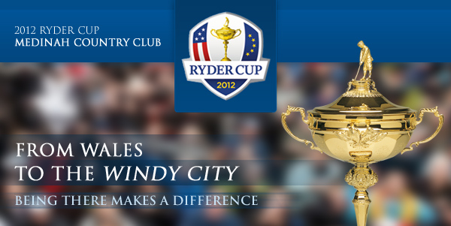
RYDER CUP 2012
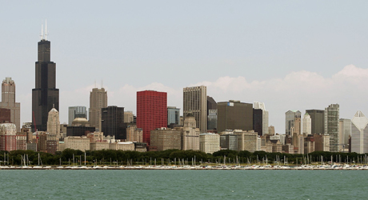
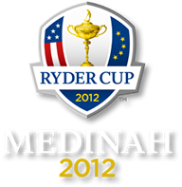

September 24-30, 2012

Broach Sports Tours’ 2012 Ryder Cup customized package includes:

- 4 nights’ accommodations
- Breakfast daily
- Ryder Cup tickets for Thursday - Sunday includes Opening and Closing ceremonies
- Roundtrip transportation to Medinah Country Club each day
- Ryder Cup gift
- Broach Sports Tours host
- All taxes and service fees

Sheraton Suites, Elk Grove IL - 9 miles to Medinah Country Club. A recent $18 million renovation, spacious suite features a separate bedroom and living room; Starbucks Coffee shop and free high speed Internet access; minutes away from the famous Woodfield Shopping Mall, Arlington Park Race Course and O’Hare.

- Price per person: triple occupancy: $1911; double occupancy $2171; single occupancy: $2664

Hotel Arista, Naperville IL - 17 miles to Medinah Country Club. Only 3 Arista hotels (New York, Paris and Naperville). Deep soaking tubs with separate showers, vanity mirrors with built-in TVs, touch-control lighting, Wi-Fi, iPod® docking station, 42-inch flat-panel HDTV in-room, laptop size safes, plush bathrobes, pillow menu; in-room coffee/tea bar; personal preference stocked.

- Price per person: triple occupancy: $2086; double occupancy $2321; single occupancy: $2871

Deposit: 30% per person with check, VISA or Master Card – add 2% for AMEX. Balance due 90 days prior.

Broach Golf Tours
Nationwide 800-849-6345 Charlotte 704-365-6500
Options:

- Upgrade to International pavilion badges
- Play golf: Cog Hill/Dubsdread. American Club: 2010 PGA - 4 World Class Links Courses
- Airport transfers or Rental Car
- Popular Destinations: Historic Long Grove 17.0 miles; Rush Street (Downtown Chicago) 20.0 miles
- Recreation: Brookfield Zoo 15.0 miles; Shedd Aquarium 20.0 miles
- Transportation: Chicago O’Hare International Airport 8.0 miles; Chicago Midway Airport 28.0 miles
- Limited Rooms at new Chicago's Radisson Blu Aqua hotel on the Miracle Mile

Itinerary:

You have options of 1) check in on Wednesday and out on Sunday 2) in on Thursday and out on Monday 3) Let us know if you want to add a 5th night. We can provide airport transfer to hotel. On Thursday we will transfer you to and from Medinah CC for the practice round and opening afternoon ceremony at 4 pm. On Friday, Saturday and Sunday you will travel to the Ryder Cup where you can experience a total of 28 matches, played in three different forms of match: After the Ryder Cup, let us know if you would like to extend your stay in Chicago or plan a golf excursion

Contact our golf director Carlos McCracken for questions or to customize your Ryder Cup experience.

Broach Golf Tours
5821 Fairview Road Charlotte, NC 28209
Nationwide 800-849-6345 Charlotte 704-365-6500
Carlos McCracken, Golf Director 704-814-6801
carlos@broachsportstours.com

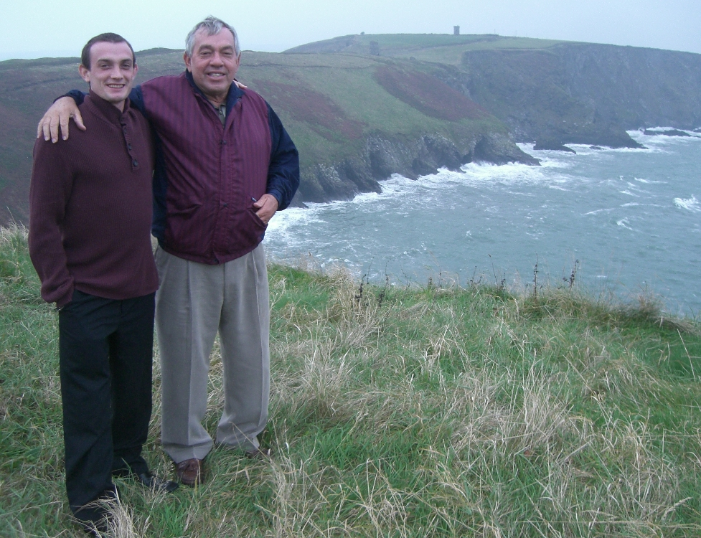
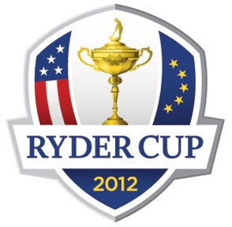
Carlos and his son Kevin at 2010 Ryder Cup

“Foursome” 8; “Four-Ball” 8; “Single” 12

“Foursome” play is a match where two golfers compete on a team against two golfers from another team and each side plays one ball. The golfers play alternate shots until the hole is played out. Team members alternate playing the tee shots, with one golfer hitting the tee shot on odd-numbered holes and the other hitting the tee shot on even-numbered holes. The team with the lower score wins the hole. Should the two teams have the same score, the hole is halved. The “Foursome” format is played on Friday morning and again on Saturday morning. Four 2-man teams from the U.S. will play against four 2-man teams from Europe each day.

“Four-Ball” play is a match in which each member of the two-man teams plays his own ball. Four balls are in play on each hole. The lowest score from each side will represent the score for the side. The side with the lowest score will win the hole. Should players from each side tie the lowest score, the hole is halved. The “Four-Ball” format is played on Friday afternoon and again on Saturday afternoon. Four 2-man teams from the U.S. will play against four 2-man teams from Europe each day.

“Single” is a match in which one player from the U.S. Team competes against another player from the European Team, each playing his own ball. The player with the lowest score on each hole will win the hole. A player wins this head-to-head competition when he is up by more holes than there are remaining to play. On Sunday, all twelve team members from the U.S. Team will compete against the European Team.
The Ryder Cup (officially the Ryder Cup Matches) is a biennial golf competition between teams from Europe and the United States. The competition is jointly administered by the PGA of America and the PGA European Tour, and is contested every two years, the venue alternating between courses in the United States and Europe. The Ryder Cup is also the name of the trophy, after the person who donated it, Samuel Ryder. The Ryder Cup, and its counterpart the Presidents Cup, are unique in the world of golf, and possibly professional sports, since despite being high-profile events that bring in tens of millions of dollars in TV and sponsorship revenue^{[1]} the players receive no prize money and compete purely for the victory.^{[2]}
The competition began following an exhibition match in 1926 between a team comprising American professionals against a similar one drawn from the British PGA on the East Course, Wentworth Club, Virginia Water, Surrey, UK. The first competition took place in 1927 at the Worcester Country Club, in Worcester, Massachusetts.
Early matches between the two sides were fairly even, but after the Second World War, repeated US dominance^{[3]} led to a decision to extend the representation of the British and Irish^{[4]} team to include continental Europe in 1979. This change was partly prompted by the success of a new generation of Spanish golfers of the time, including Seve Ballesteros and Antonio Garrido, who, in 1979, became the first Spaniards to play in the event. Since then, Team Europe has included players from Denmark, France, Germany, Italy, and Sweden.
Following this change, the event has enjoyed more competitive matches, with Europe winning eight times outright and retaining the Cup once by tying, and with seven American wins over this period.
TEAM SELECTION

United States
A points system will determine the top eight players for USA. The points will be based upon the following:
• Prize money earned in major championships (Masters, U.S. Open, British Open and PGA Championship ~ one point for every $1,000 earned).
• Prize money earned in “official events” from January 1 through August 11 (one point for every $1,000 earned, excluding the major championships and events played opposite major championships and opposite World Golf Championships).
• Prize money earned in major championships (Masters, U.S. Open, British Open, PGA Championship ~ two points for every $1,000 earned).
• Prize money earned in events played opposite the major championships and opposite World Golf Championship events between January 1 and August 11 (one-half point for every $1,000 earned).

The United States Team Captain, will make four selections to complete the 12-man team.

FORMAT OF THE RYDER CUP

There are a total of 28 matches, played in three different forms of match play as follows:
“Foursome” 8
“Four-Ball” 8
“Single” 12

Foursome
“Foursome” play is a match where two golfers compete on a team against two golfers from another team and each side plays one ball. The golfers play alternate shots until the hole is played out. Team members alternate playing the tee shots, with one golfer hitting the tee shot on odd-numbered holes and the other hitting the tee shot on even-numbered holes. The team with the lower score wins the hole. Should the two teams have the same score, the hole is halved. The “Foursome” format is played on Friday morning and again on Saturday morning. Four 2-man teams from the U.S. will play against four 2-man teams from Europe each day.

Four-Ball
“Four-Ball” play is a match in which each member of the two-man teams plays his own ball. Four balls are in play on each hole. The lowest score from each side will represent the score for the side. The side with the lowest score will win the hole. Should players from each side tie the lowest score, the hole is halved. The “Four-Ball” format is played on Friday afternoon and again on Saturday afternoon. Four 2-man teams from the U.S. will play against four 2-man teams from Europe each day.

Single
“Single” is a match in which one player from the U.S. Team competes against another player from the European Team, each playing his own ball. The player with the lowest score on each hole will win the hole. A player wins this head-to-head competition when he is up by more holes than there are remaining to play. On Sunday, all twelve team members from the U.S. Team will compete against the twelve team members from the European Team.

RYDER CUP TERMINOLOGY

Match Play
A game played by holes, and not by cumulative score.

How is a hole won?
A hole is won by the team with the lowest score on that particular hole. For example, if Team A makes a 3 on Hole 1 and Team B makes a 5 on Hole 1, Team A wins the hole and would be 1-up for the match.

How is score kept for match play?
Score is kept by the number of holes “up” (won) and the number of holes to play. For example, if Team A wins the first hole, they would be 1-up with 17 holes to play.

All Square
If a match is tied or level while in competition, then it is considered “all square.” For example, if both teams make a 3 on Hole 1, then the match would be “all square” with 17 holes to play.

Dormie
A side is considered “dormie” when it is as many holes up as there are holes remaining to be played. For example, if Team A were 2-up with two holes to play, Team A would be “dormie.”

When does one team win the match?
A team will win the match when one side is up by more holes than there are holes remaining to be played. For instance, if Team A is 2 holes up with only 1 hole to play, the match is over and one point is awarded to the winning team, Team A.

How many points can you win during each match?
Only one point is awarded for each match won.

Concession
A player may concede an opponent’s next stroke at any time provided the opponent’s ball is at rest. The opponent is considered to have holed out with his next stroke and the ball may be removed by either side. A player may concede a hole at any time prior to the start or conclusion of that hole. A concession may not be declined or withdrawn.

The Tradition of the Ryder Cup

The Ryder Cup is golf’s most spirited competition, with an unwavering tradition of sportsmanship and respect among the teams, match officials and galleries. Players and spectators alike are expected to conduct themselves in a manner which respects this tradition throughout Ryder Cup Week. Applause and cheering by spectators should show encouragement and support of all players. Booing or jeering is inappropriate. Spectators who breach this conduct by directing profanity or insult toward a player or official at any time, or who act in an inappropriate or unethical manner, will be immediately removed from the grounds. Your support of this tradition and adherence to the conduct is expected.

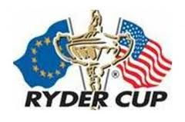

Medinah No 3 has taken its place among the roll of honour of top American golf courses.
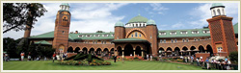

The 2012 Ryder Cup venue was ranked No 37 in the Top 100 Courses in the US according to the biennial list released by the respected Golf Magazine late in 2011. Incidentally, nearby Cog Hill came in at No 89.
The rankings were determined by a panel of 100 members, comprised of Ryder Cup players, architects, amateur champions, photographers, journalists, historians and course connoisseurs.

Broach Golf Tours
5821 Fairview Road Charlotte, NC 28209
Nationwide 800-849-6345 Charlotte 704-365-6500
Carlos McCracken, Golf Director 704-814-6801
carlos@broachsportstours.com

