
2008 US Open Tennis Championship
USTA National Tennis Center; Flushing Meadow, NY
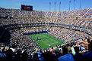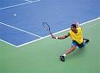

Labor Day Week-end Package and The Final Package:

Labor Day Week-end
Three and Two night Packages
August 30 – Sept. 2, 2008

Land Package for Labor Day Weekend: Includes 3 nights, 3 sessions and more for only $889 per person (based on double occupancy).

Three nights’ accommodations at the Millennium Plaza Hotel New York - Saturday, Sunday and Monday nights; 3 Tickets/Sessions to US Open in promenade - Saturday night, Sunday day & Monday day; Welcome cocktail reception on day of your arrival; Daily roundtrip transportation from hotel to US Open with host via #7; Broach Sports Tours host with insider’s tips; Daily Broach Sports Tours Hospitality in hotel. Options: air, ticket upgrades, tennis, city and harbor tours, Broadway plays.

Cost per person: Double $889; Triple $795; Single $1179

Air Package from over 50 US cities for Labor Day Weekend: Includes air, 2 nights and 2 sessions for $959 per person (based on double occupancy).

Two nights’ accommodations at The Millennium Plaza Hotel in Manhattan - Saturday and Sunday nights; 2 Tickets/Sessions to the US Open in promenade - Saturday night evening session & Sunday day session; Welcome cocktail reception on day of your arrival; Daily roundtrip transportation from hotel to US Open with host via #7; Broach Sports Tours host with insider’s tips; Daily Broach Sports Tours Hospitality in hotel; Airfare departing from selected US cities.
Options: add Monday US Open ticket, ticket upgrades, tennis, tours.

Cost per person: Double $889; Triple $749; Single $1179

After arrival in NYC on Saturday, you have the day free to enjoy the many interesting sights of NYC including the US Open Live. We will meet at 4:30 pm for a cocktail social before we depart for the evening session at The U S Open -- nothing like being at the US Open at night. We will meet in the lobby each morning to travel to the action at the Open that begins at 11:00 am. The Millennium Hotel has spectacular views of New York, rooftop pool and is the only hotel in Manhattan with tennis court. It is only a 5-minute walk (3 blocks) to Grand Central Station where we will take the # 7 to the Open and 7 blocks from Time Square. You are invited to our hospitality suite each evening to share your NYC and US Open experiences. You will have the day of departure to do some shopping and site seeing before returning home.

Loge seating upgrade add: Saturday night - $185; Sunday day - $275; Monday day - $175

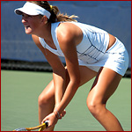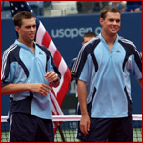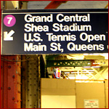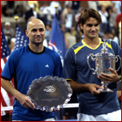

US Open 2008 Finals Week-End
Friday, August 29 - Monday, Sept. 8, 2008

Land Package for Finals Weekend with air from over 50 US cities: Includes 3 nights, Men’s semis, Men’s finals, and Women’s doubles finals for only $1995 per person (based on double occupancy).

Three nights’ accommodations at The Millennium Plaza Hotel in Manhattan – Saturday, Sunday, Monday nights; Official US Open Reserved Promenade seating for Saturday day and Sunday matches – men’s semis, men’s finals, and women’s doubles finals; Transfers to and from US Open via #7; All hotel taxes.
Options: Sightseeing, shopping, Broadway plays, ticket upgrades, extra nights, tours.

Cost per person: Double $1995; Triple $1625; Single $2665
Optional: Add Friday day or eve session US Open session for $128 per person or Sat. night US Open session for women finals for $155 per person. Call for loge and courtside seating upgrades.
Same air package with Loge seating: $3695 (limited loge tickets at this price – call to confirm)
After arrival in NYC on Friday, you have the day free to enjoy the many interesting sights and sounds of NYC including the US Open Live. We will be glad to help you plan your day and book tours of NYC. Come by our hospitality room to share your New York and US Open experience each day. The Millennium Hotel has spectacular views of New York, rooftop pool and is the only hotel in Manhattan with tennis court. We will meet in the lobby to travel to the US Open on Saturday and Sunday -- it is a 5-minute walk (3 blocks) to Grand Central Station where we will take the # 7 to the Open. You will have Monday to do some shopping and site seeing before returning home.

The Millennium Plaza Hotel, New York
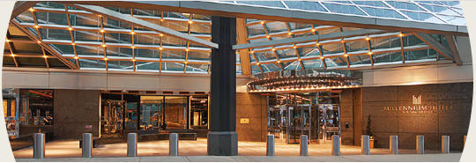
Overview: The Millennium Plaza is more than a hotel; it is truly a New York experience. A place for those who expect the highest standards of personal service. Our luxury, European-style hotel, with guest rooms located on floors 28 through 40, provides spectacular views of the Manhattan skyline and East River.
Here, serenity is customary and is enhanced by the contemporary decor highlighting marble, chrome and glass while incorporating vibrant colors and fresh flowers.
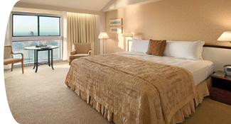
Rooms: Rooms offer many unique vantage points such as rooms beginning on the 28th floor, all affording spectacular views, the East River runs by the historical site of the United Nations, West of the hotel, you can enjoy the breathtaking views of the NYC skyline and Chrysler building. In room amenities include king, queen or two twin beds with satellite TV, pay movies high speed internet access air conditioning, mini bar, safe, iron and board, hairdryer, radio alarm clock and complimentary newspaper. All guest rooms will be in the brand new East Tower. Large rooms, unique to NYC.
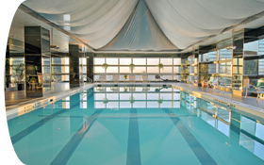
Facilities:
Fitness Center with State-of-the-art Fitness Equipment
Heated Indoor Pool
Massage and Sauna
Indoor Tennis Court on the 39th Floor
Nearby Points of Interest
United Nations Headquarters - across the street
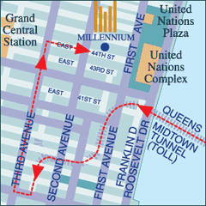
Broadway Theater District/Times Square - 6 blocks
Great Dining - Everywhere!
East River - 1 block
Chrysler Building - 3.5 blocks
Grand Central Terminal - 3.5 blocks
Fifth Avenue - 5 blocks
New York Public Library/Bryant Park - 6.5 blocks
Rockefeller Center/Radio City Music Hall - 9 blocks
Saks Fifth Avenue - 9 blocks
Empire State Building - 16 blocks
Bloomingdales - 16 blocks
Central Park - 1.25 miles
Metropolitan Museum of Art - 2.25 miles
LaGuardia Airport (LGA): Approximate driving time to the Millennium UN Plaza Hotel is 18 minutes and distance is 9 miles.
Did you know-- if you have some non-tennis fans going they can enjoy:

At 1,255 acres, Flushing Meadows Corona Park is one and a half times the size of Manhattan's Central Park.
.
The park is so big that it plays host to the New York Mets at Shea Stadium and US Open Tennis, as well as to hundreds, even thousands, of visitors who come for weekend picnics, strolls, festivals, soccer games, and other activities. There are two lakes, a pitch-and-putt golf course (miniature golf), playing fields, picnic areas, and bicycle rental stands (more on park activities).
The Park is home to the Queens Museum of Art (and its amazing diorama of NYC's five boroughs), the New York Hall of Science (an interactive science learning center), the Queens Zoo, the Queens Theatre in the Park, and the Queens Botanical Garden. The park hosts several annual festivals, including the Colombian Independence Day Celebration (one of the largest Latino events in NYC) and the Dragon Boat Festival.
The World's Fair was held in Flushing Meadows Park twice: in 1939-40 and again in 1964-65. Two towers from the 1964-65 World's Fair -- also featured in Men in Black -- still dominate the area's skyline, though they are in a sorry state. Other facilities from the fairs include the NYC Building (housing the museum and an ice rink), the Unisphere, and numerous statues and monuments.

"Our trip to the U.S. Open tennis tournament was FANTASTIC! Broach Sports Tours, Carlos, and his associates could not have done any more to make sure that every client on this trip had the best experience possible. They took care of every detail and went above and beyond expectations on numerous occasions. Our accommodations were wonderful (Maria Sharapova even stayed there). Throughout the event they worked to upgrade our seats and stayed in contact to see if there was anything else they could do for us. Thanks for a memory that will last a lifetime!"

Mark McClure: Your US Open travel package was perfect - all of my expectations were exceeded. In addition to spectacular tennis at Flushing Meadows I compliment you on your choice of the hotel. That was a great location for a short subway ride to the Open and easy access to mid and lower Manhattan. I wanted to get familiar with Manhattan and I did thanks to being in a central location. Thanks for being available for sightseeing tips and guidance. Thanks also for the gifts you included in your trip package and the surprise limo ride to the Open. And thanks for the US Open stadium seating tips and the Sharapova sightings. I never did go to my purchased seats!

Call for Reservation or Questions:
1-800-849-6345
or
Tennis Director, Carlos McCracken, direct line: 704-814-6801
www.broachsportstours.com/tennis

Scotland Golf - 2008 Masters - 2009 Australian - 2008 French - 2008 Wimbledon – 2008 Ryder Cup

