2014 French Open Tennis Championship
Stade Roland Garros, Paris, France

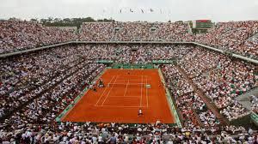

Below is our 2014 French Open Package with $300 pp discount for those booking by March 3

- Five nights hotel accommodations
- Court Chatrier tickets for the 2014 French Open for Monday, May 26 and Tuesday, May 27, elite VIP seating is all that remains.
- Metro Pass
- City and metro maps; restaurant and museum guides
- Round trip air from 50 US cities
- Travel and Roland Garros and Paris assistance
- All taxes and service charges included
- Museum pass

Cost per person double at 3 -star Hotel Poussin: $4411 per person double occupancy, private $4811.

Cost per person double at 4 -star Marriott Opera Ambassador: $5213 per person double occupancy; private $5613.

Options:

Let us know if you want to us to customize your trip with different dates.
Land only: no air subtract $945
Airport transfers
Paris sightseeing tours, Seine River Cruise ,Day tour to Monet's gardens and home or Versailles
Extra nights Poussin $350, Marriott Opera Ambassador $500

Itinerary:

May 24, 2014 - Depart US am arrive Paris AM on 25th
May 25 - Enjoy Paris
May 26 and May 27- All day at Roland Garros
May 28, 29 - Enjoy Paris
May 30- depart Paris or let us help you extend your trip into France, England or Europe

BROACH SPORTS TOURS
3235 South Blvd., Charlotte, NC 28209
Charlotte (704) 365-6500 Raleigh (919) 380-7476
Nationwide (800) 849-6345 Fax (704) 365-3800

Hotel Poussin
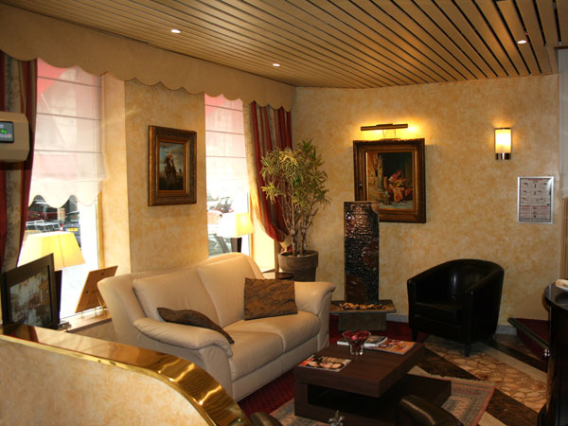
The hotel is a 5 -7 minute walk to Roland Garros stadium, near the Parc des Princes, The Racecourse of Longchamp and Auteuil's and Coubertin stadium i the edge of the Bois de Boulogne, a place quiet and situated well by connections in all the demonstrations and Parisian monuments; in a building character, the reserves you a personalized reception, emanating the tenderness and the charm of a lounge art-déco on the ground of marble and a terrace with sight on the roofs of Paris...n the Edge of the Bois de Boulogne, a place quiet and well Situated by connections in all The Demonstration and Parisian monuments in a character building, The Hotel Poussin reserves you a personalized reception, emanating The Tenderness & the charm of a lounge-art Deco on the ground of marble and a terrace on the roof With sight of Paris. Rooms include:
- Sound damping
- Hairdryer
- Float screen TV
- International network direct telephone
- Mini bar
- Individual safe

"The Hotel Poussin is a small, simple, and charming hotel, very Parisian in every way. We loved it, especially after discovering that a hidden patio on an upper floor offered us the view of the Eiffel Tower! No sooner did we discover it that we made it our special place at the end of the day to enjoy a glass of wine and toast to the day's events, which included only tennis! The seats at Roland Garros, where as expected......great. We were able to extend our stay by one day to allow us to see the postponement of the men's finals and the hotel was happy to accomodate us......in an even better room. In summary, everything we were promised was delivered, and we would not hesitate to use Broach Sports Tours again for another tennis event.”

Roland Garros Information

Restaurants: Spectators restaurant for the public (600 capacity) beneath Court Philippe Chatrier (Centre Court) Stand D. You can also use one of the three stadium restaurants: The "Passing", under Court n1’s scoreboard; The "Terrasse", located under the South stand of Court Suzanne Lenglen; The "Buffet" on the CNE esplanade. The "Buffet" is a restaurant of approximately 1000m² which can seat up to three hundred people. Half of the seats are sheltered in case of rain. There are also numerous kiosks all around the stadium.

Medical Assistance: Three infirmaries are open to the public inside the stadium: at Court Philippe Chatrier (Centre Court), under stand B; at Court n1, facing the "Village"; and at Court Suzanne Lenglen, under the East stand

Lunch or dine at a very special venue: The Roland-Garros Restaurant
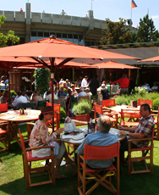
Located right at the heart of clay court paradise, the Roland-Garros restaurant offers original and refined creations allying tradition with modernity. The glass panels and brick walls, plus the superb rotisserie and fireplace, make it the ideal cosy refuge. On the garden side, the Roland-Garros opens onto a flower-filled terrace facing the famous Centre Court, allowing you to savour those fine summer days to the full.
The Roland-Garros is at 2bis, avenue Gordon-Bennett — 75016 Paris Tel. : 01 47 43 49 56 - M° Porte d’Auteuil. Valet-parking service at lunchtime.

Testimonials

U.S. Open 2013

When a group travels together, as I have observed over many years, there always seem to be two “little old ladies” on the trip. Now I am astounded to realize that WE are the two “little old ladies” on the trip! Iris and I are age 87 and 79 and took a chance that we could keep up with John Delong and others on our tour to the US Open tennis tournament on Labor Day Weekend in 2013. John was a great inspiration, via email before the trip and also throughout the trip. He helped us in every way possible. He accompanied us from the hotel to the stadium, via walking and subway, and he checked on us frequently throughout the days. We had an absolutely fantastic experience and we will surely recommend Broach Sports Tours whenever an occasion arises.

Betty Clarke and Iris Kennedy
Virginia Beach, Va.

Our trip to the US Open was fantastic. It was a trip we had been wanting to do for some time, and we were not disappointed. John from Broach Sports Tours was very helpful and organized. Since neither my husband nor I had been to New York since we were kids, we weren’t terribly comfortable with the idea of navigating New York’s subway system. John escorted us from the hotel to Grand Central Station and onto the train to the US Open site. He rode with us on the subway and pointed out various features of the site once we arrived. At that point, we were fine with being on our own, and he gave us that space. The bottom line, it was nice knowing we had a guide we could call on if necessary, but that let us do our own thing when we were ready. He checked in on us a couple of times to make sure we were OK. The goody bag and subway passes were a nice touch, as was the breakfast buffet at the hotel. We are hoping to go back in the future.

Theresa and Burt Anderson
Valrico, Fla.

Wimbledon 2013

Hey John,

I thoroughly enjoyed my Wimbledon experience. From the hotel to the tube ride and the experience at the All England Club, everything was well-coordinated. You provided a nice group experience while allowing us also to explore and enjoy Wimbledon and London on our own. BTW – the gift bags and treats inside were an added bonus after a long day’s travel.

Elizabeth Barnhardt
Charlotte, N.C.

Hello John,

Was a fun trip by ALL and the seats were fantastic. We saw some great tennis matches. Thanks for your kindness and we appreciate your efforts on our behalf.

Fred and Jean Gale
Copley, Ohio

Thanks, John.

We had a great time. We are definitely not group tour folks, so we found the amount of interaction as a group just perfect. The hotel was convenient and we used the Oyster card and city touring, enjoying it very much. Thanks for the work you and Debbie did to make it a pleasant experience!

Susan Ritz
Montpelier, Vt.

Hello John,

Thanks so much for a great trip. I appreciate all that you and Debbie did for us! I’d go back to London tomorrow!!!

Paula and Mike Porter
Treasure Island, Fla.

Roland Garros 2013

John,

The trip was wonderful and I loved every minute of tennis and touring Paris! The weather could have been a bit better, but we have no control over that. The seats in Phillippe Chatrier were great and having access to the hospitality area was fantastic. I would have preferred to also have access to Suzanne Lenglen and Court One as a number of very good matches were played on those courts, so that was a disappointment. I thought the hotel was fine, the location was ideal. Thank you for your efforts on this tour and good luck with your future trips.

Beth Motley
Richmond, Va.

Dear John,

I wanted to send you a note to thank you for a fine trip. Everything included was very useful and we got our money’s worth on the Metro. I think the location of the hotel is great. Being close to the tennis is a real plus to me. I found the hotel very adequate. I would recommend it in the future. Thanks again and enjoy the summer.

Carolyn Tierney
Montclair, N.J.

Hi John,

Thank you so much for arranging everything! We had a great time despite the weather! Having never travelled to a foreign country before, I could not compare hotel rooms, but ours was not bad although tight. But very Parisian I would say. It was in the perfect location! From access to Roland Garros and Metro stations to a wonderful neighborhood with cafes, shops and bakerys. In my opinion you should use it again. Thank you again. Have a great summer.

Nancy and Greg Koontz
Richmond, Va.

BROACH SPORTS TOURS
3235 South Blvd., Charlotte, NC 28209
Charlotte (704) 365-6500 Raleigh (919) 380-7476
Nationwide (800) 849-6345 Fax (704) 365-3800

John Delong, Tennis Director
john@broachsportstours.com
704-365-6500
1-800-849-6345

