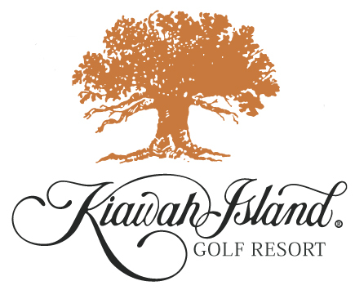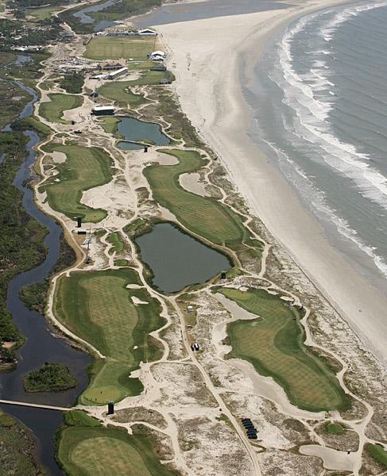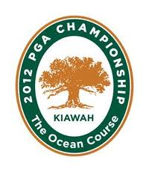

2012 PGA Championship
August 10 - 13, 2012
Kiawah Island, SC

Broach Golf Tours PGA Championship Package

- 2 night's accommodations at Sheraton Hotel check in on Friday August 10 and out on Monday August 13, 2012
- Championship ticket for Saturday and Sunday to The PGA Championship
- Roundtrip transfers to The PGA Championships
- Broach Golf Tours Assistants and concierge serves for Charleston and The Championship
- All taxes and service fees

Price per person:

$781 double; $734 triple; $692 quad; $1,028 private

Options:

- Ticket Upgrades: Wanamaker Club Badges add $70 per person
- Stay additional nights and enjoy Charleston.
- Roundtrip air
- Rental car
- Extend your stay to enjoy Charleston and play golf

Broach Sports Tours
3235 South Blvd., Charlotte, NC 28209
Nationwide 800-849-6345 Charlotte 704-365-6500
Raleigh 919-380-7476 Fax 704-365-3800
Carlos McCracken, Golf Director 704-814-6801

BROACH SPORTS TOURS luxury motorcoach days trips from Charlotte, NC to The 2012 PGA Championship
on Saturday and Sunday on August 11 and 12, 2012

2012 PGA Championship
August 11 and 12
Kiawah Island, SC

Days trips Saturday and Sunday

Package Includes:

-Deluxe Motorcoach from Charlotte
-Badges to Saturday or Sunday Final Rounds
-Broach Sports Tours host
-Dinner at Chestnut Grill in Orangeburg

Price per person:
$225 each day

Ticket Upgrades:
Wanamaker Club Badges +$70 additional

Itinerary:

We leave Charlotte at 6:00 am each day and you will be on the Ocean Course around 10:30. After a wonderful day of viewing the best golfers in the world on one of the most challenging courses, we depart Kiawah Island at 6:00 pm. Dinner is included at the Chestnut Grill in Orangeburg, SC. Sit back and enjoy football via DirecTV while we cruise back to Charlotte, returning home around 11:30 pm. What a day!

Broach Sports Tours
3235 South Blvd., Charlotte, NC 28209
Nationwide 800-849-6345 Charlotte 704-365-6500
Raleigh 919-380-7476 Fax 704-365-3800
Carlos McCracken, Tennis & Golf Director 704-814-6801

