**2015 US Open Tennis Championship**

USTA National Tennis Center; Flushing Meadow, NY

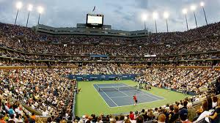

Below are two packages for the 2015 US Open Championships for Labor Day Weekend and the Finals. If you want different dates, call us at 800-849-6345 to customize your US Open adventure.

**US Open Labor Day 3-Night Weekend Package**

Saturday, Sept. 5 – Tuesday September 8, 2015

**Or**

Friday, Sept. 4 – Monday September 7, 2015

**Land Package for Labor Day Weekend:**

Three nights’ accommodations at the Millennium UN Plaza Hotel New York or W Hotel in Time Square; Three Sessions to US Open in Promenade (can upgrade to loge or courtside) - Saturday night, Sunday day and Monday day; Welcome reception on Saturday with insider tips to the Open before departing for the Saturday evening session; Daily roundtrip transportation from hotel to US Open with host via #7 and the new water taxi; Broach Sports Tours tennis host with insider’s tips; All taxes and service fees.

**Cost per person at The Millennium Hotel:** Double $871; Triple $764; Single $1282

**Cost per person at W Hotel in Times Square:** Double Occupancy $1041; Single $1582

**Options:** Roundtrip Air, Play tennis, NYC city and harbor tours, Broadway plays, ticket upgrades:

**Loge upgraded ticket add: Courtside upgraded tickets add:**

Friday night $145 $415

Saturday day $315 $1175

Saturday night $185 $675

Sunday day $210 $725

Sunday night $175 $555

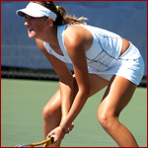After arrival in NYC on Friday or Saturday, you have the day free to enjoy the many interesting sights of NYC including the US Open Live.  Let us know if you want to attend the US Open for another session or take in a Broadway show or a NYC tour. You will connect with our US Open tennis host on your arrival to welcome you and give you insider’s tips to enjoying the Open and NYC. We will meet in the lobby each morning to travel to the matches that begin at 11:00 am.  The Millennium Hotel has spectacular views of New York, rooftop pool and is the only hotel in Manhattan with a tennis court.  It is only a 5-minute walk (3 blocks) to Grand Central Station where we will take the # 7 to the Open and 7 blocks from Time Square.  You are invited to our hospitality suite each evening to share your NYC and US Open experiences.  On day of departure plan some shopping and sightseeing before leaving NYC.

**Broach Sports Tours**

3235 South Blvd., Charlotte, N.C. 28209

Office: 800-849-6345

**US Open 2015 Championship Weekend**

Friday, September 11 - Monday, September 14, 2015

4 days and 3 nights

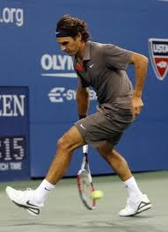

* Three nights’ accommodations – Friday, Saturday and Sunday;
* Official US Open Reserved Promenade seating (can upgrade to loge or courtside) for Three Sessions: Friday day men’s semifinals, Saturday women’s finals; Sunday men’s finals.
* Welcome reception to provide insider tips to the Open and NYC,
* Transfers to and from US Open via #7;
* Broach Tennis Tour host for insider tips to The Open and concierge services to NYC;
* All taxes and service fees.

**Cost per person at The Millennium Hotel:** Double Occupancy $1731

**Cost per person at W Hotel in Times Square:** Double Occupancy $2146

**Options:**

Loge upgrades $1735

Courtside seating upgrades call for current pricing

Private Transfers

NYC tours

Broadway Plays

Play tennis in NYC

Roundtrip air

After arrival in NYC on Friday, you have the day free to enjoy the many interesting sights and sounds of NYC including the US Open Live. We will be glad to help you plan your day and book tours of NYC or a Broadway play. The Millennium Hotel has spectacular views of New York, rooftop pool and is the only hotel in Manhattan with tennis court.  We will meet in the lobby to travel to the US Open on Saturday and Sunday - it is a 5-minute walk (3 blocks) to Grand Central Station where we will take the # 7 or the water taxi to the Open.  You will have Monday to do some shopping and sightseeing before returning home.



**Broach Sports Tours**

3235 South Blvd., Charlotte, N.C. 28209

Office: 800-849-6345

**The Millennium Plaza Hotel, New York**

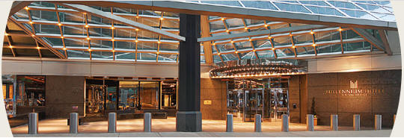

**We have stayed at the Millennium for last 7 years and they provide us excellent service. There are two towers of rooms that have the best views of the NYC in all of Manhattan. The hotel is doing a $12 million remodeling in one tower that all rooms will be ready for our 2012 US Open Tour. Bring your racquet - it is the only hotel in NYC with a tennis court. Many of the tennis players stay here.**

**Overview:**

The Millennium Plaza is more than a hotel; it is truly a New York experience.  A place for those who expect the highest standards of personal service. Our luxury, European-style hotel, with guest rooms located on floors 28 through 40, provides spectacular views of the Manhattan skyline and East River.   
  
Here, serenity is customary and is enhanced by the contemporary decor highlighting marble, chrome and glass while incorporating vibrant colors and fresh flowers.

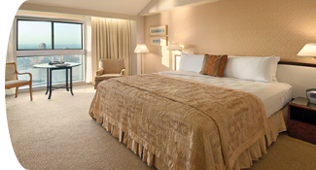**Rooms:**

Rooms offer many unique vantage points such as rooms beginning on the 28th floor, all affording spectacular views, the East River runs by the historical site of the United Nations, West of the hotel, you can enjoy the breathtaking views of the NYC skyline and Chrysler building. In room amenities include king, queen or two twin beds with satellite TV, pay movies high speed internet access air conditioning, mini bar, safe, iron and board, hairdryer, radio alarm clock and complimentary newspaper. All guest rooms will be in the brand new East Tower. Large rooms, unique to NYC.

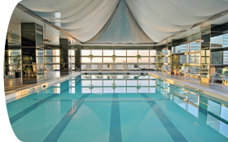**Facilities:**

Fitness Center with State-of-the-art Fitness Equipment

Heated Indoor Pool

Massage and Sauna

Indoor Tennis Court on the 39th Floor

**Nearby Points of Interest:**

United Nations Headquarters - across the street

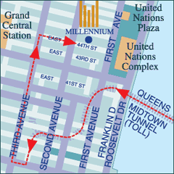Broadway Theater District/Times Square - 6 blocks

Great Dining - Everywhere!

East River - 1 block

Chrysler Building - 3.5 blocks

Grand Central Terminal - 3.5 blocks

Fifth Avenue - 5 blocks

New York Public Library/Bryant Park - 6.5 blocks

Rockefeller Center/Radio City Music Hall - 9 blocks

Saks Fifth Avenue - 9 blocks

Empire State Building - 16 blocks

Bloomingdales - 16 blocks

Central Park - 1.25 miles

**Broach Sports Tours**

3235 South Blvd., Charlotte, N.C. 28209

Office: 800-849-6345

Testimonials

U.S. Open 2013

When a group travels together, as I have observed over many years, there always seem to be two “little old ladies” on the trip. Now I am astounded to realize that WE are the two “little old ladies” on the trip! Iris and I are age 87 and 79 and took a chance that we could keep up with John Delong and others on our tour to the US Open tennis tournament on Labor Day Weekend in 2013. John was a great inspiration, via email before the trip and also throughout the trip. He helped us in every way possible. He accompanied us from the hotel to the stadium, via walking and subway, and he checked on us frequently throughout the days. We had an absolutely fantastic experience and we will surely recommend Broach Sports Tours whenever an occasion arises.

Betty Clarke and Iris Kennedy

Virginia Beach, Va.

Our trip to the US Open was fantastic. It was a trip we had been wanting to do for some time, and we were not disappointed. John from Broach Sports Tours was very helpful and organized. Since neither my husband nor I had been to New York since we were kids, we weren’t terribly comfortable with the idea of navigating New York’s subway system. John escorted us from the hotel to Grand Central Station and onto the train to the US Open site. He rode with us on the subway and pointed out various features of the site once we arrived. At that point, we were fine with being on our own, and he gave us that space. The bottom line, it was nice knowing we had a guide we could call on if necessary, but that let us do our own thing when we were ready. He checked in on us a couple of times to make sure we were OK. The goody bag and subway passes were a nice touch, as was the breakfast buffet at the hotel. We are hoping to go back in the future.

Theresa and Burt Anderson

Valrico, Fla.

Wimbledon 2013

Hey John,

I thoroughly enjoyed my Wimbledon experience. From the hotel to the tube ride and the experience at the All England Club, everything was well-coordinated. You provided a nice group experience while allowing us also to explore and enjoy Wimbledon and London on our own. BTW – the gift bags and treats inside were an added bonus after a long day’s travel.

Elizabeth Barnhardt

Charlotte, N.C.

Hello John,

Was a fun trip by ALL and the seats were fantastic. We saw some great tennis matches. Thanks for your kindness and we appreciate your efforts on our behalf.

Fred and Jean Gale

Copley, Ohio

Thanks, John.

We had a great time. We are definitely not group tour folks, so we found the amount of interaction as a group just perfect. The hotel was convenient and we used the Oyster card and city touring, enjoying it very much. Thanks for the work you and Debbie did to make it a pleasant experience!

Susan Ritz

Montpelier, Vt.

Hello John,

Thanks so much for a great trip. I appreciate all that you and Debbie did for us! I’d go back to London tomorrow!!!

Paula and Mike Porter

Treasure Island, Fla.

Roland Garros 2013

John,

The trip was wonderful and I loved every minute of tennis and touring Paris! The weather could have been a bit better, but we have no control over that. The seats in Phillippe Chatrier were great and having access to the hospitality area was fantastic. I would have preferred to also have access to Suzanne Lenglen and Court One as a number of very good matches were played on those courts, so that was a disappointment. I thought the hotel was fine, the location was ideal. Thank you for your efforts on this tour and good luck with your future trips.

Beth Motley

Richmond, Va.

Dear John,

I wanted to send you a note to thank you for a fine trip. Everything included was very useful and we got our money’s worth on the Metro. I think the location of the hotel is great. Being close to the tennis is a real plus to me. I found the hotel very adequate. I would recommend it in the future. Thanks again and enjoy the summer.

Carolyn Tierney

Montclair, N.J.

Hi John,

Thank you so much for arranging everything! We had a great time despite the weather! Having never travelled to a foreign country before, I could not compare hotel rooms, but ours was not bad although tight. But very Parisian I would say. It was in the perfect location! From access to Roland Garros and Metro stations to a wonderful neighborhood with cafes, shops and bakerys. In my opinion you should use it again. Thank you again. Have a great summer.

Nancy and Greg Koontz

Richmond, Va.

**Broach Sports Tours**

3235 South Blvd., Charlotte, N.C. 28209

Office: 800-849-6345